INTRODUCTION

Coronavirus 2, same as SARS-CoV-2, associated with the Severe Acute Respiratory Syndrome, initially referred to as 2019 –nCoV and later officially named as COVID-19 by the World Health Organization (WHO), emerged in Wuhan (Hubei Province, China), in December 2019, and later spread quite rapidly beyond the borders of China. The WHO declared the public health emergency of international concern on January 30, 2020, and a pandemic on March 11. Five months after the virus inception, more than 4,000,000 persons were infected in 210 countries, 288,000 died and over 1,500,000 recovered. This is the third zoonotic coronavirus outbreak in the 21st century, when the human-to-human transmission of the infection occurred and caused a global health problem. The spread of the infection is particularly intense in the United States, Spain, Russia, the United Kingdom, Italy, France, Germany, Brazil, Turkey, Iran, while China, the initial source of pandemic, moved out from its previous position and now follows the top ten countries that were hit with the highest rate of damage. Although, COVID-19 is characterized by a high frequency of transmission, the identified cases differ with their severity from asymptomatic to fatal. Various factors, including age, gender, and underlying health conditions, are considered to be associated with a negative outcome.

The National Center for Disease Control and Public Health (NCDC) has been playing an important role in Georgia's response against COVID-19. Responsibilities of the Center, among others, involve preparedness and response measures. These include real-time epidemiological surveillance, management of novel coronavirus laboratory diagnostics and supervision of compliance with standards, epidemiological surveillance over confirmed and suspected cases, tracing, isolation recommendations, and monitoring.

This document represents the first summarizing analysis of the epidemiological situation and measures taken against spread of the novel coronavirus in Georgia. This type of analysis will be regularly updated once a month during the pandemic.

GENERAL OVERVIEW

Testing: Testing with PCR method to detect COVID-19 in Georgia began on January 30, 2020. The number of tests (primary and repeated) conducted in the country from January 30 to May 11 was 32,283, including repeatedly ones - 1 392.
For PCR testing, nasopharyngeal sputum or smear, bronchoalveolar lavage (fluid) or respiratory biopsy material may be taken, however, the other materials such as feces and / or blood and / or urine / or corpse tissue (from lung) with special indications can also be used for this type of testing.
The PCR method is considered as the gold standard in the COVID-19 diagnostics. Its advantages are high sensitivity and specificity, which minimize the risk of false-positive (as well as false-negative) results. However, a single negative PCR result does not exclude COVID-19, especially if the nasopharyngeal smear is taken at the early stages of the disease. It can be used in conditions where high-tech laboratory space and highly qualified staff are available.
Pursuant to the Ministerial Orders of Internally Displaced Persons from the Occupied Territories, Labour, Health and Social Affairs of Georgia, subject to testing are cases according to the standard definition, contacts of confirmed cases, patients and medical personnel of respective medical facilities meeting specific criteria, any patient with the diagnosed pneumonia or fever (who have symptoms of respiratory disease or the treating physician makes a decision on testing), emergency medical personnel and disaster brigade staff, enrolled or prospective beneficiaries and staff of day care facilities for the elderly and disabled, all persons who have been diagnosed with early-stage tuberculosis, staff of quarantine spaces, customs officers and border police, personnel of inpatient hospital reception, intensive therapy and care, the Center’s epidemiologists and staff of COVID-19 PCR Laboratory.
All cases of COVID-19 infection in Georgia were confirmed by PCR testing.
Figure 1. COVID - 19 testing dynamics in Georgia (as of May 11, 2020)

Figure 2. Positivity rate of COVID-19 tests (three-day crawling percentages) (as of May 11, 2020)

PCR testing during the period from January 30 to March 1, 2020, was carried out only by the Lugar Center of the National Center for Disease Control and Public Health. Starting from March 1, the other laboratories got gradually involved in the testing process. As of May 11, the following laboratories were conducting PCR testing:
- Lugar Center (Tbilisi)
- NCDC Imereti Division (Kutaisi)
- NCDC Adjara Division (Batumi)
- JSC Infectious Diseases, AIDS and Clinical Immunology Research Center (IDH)
- Neolab Ltd.
- Salikh Abashidze Regional Center for Infectious Diseases, AIDS and Tuberculosis Ltd (Batumi IDH)
- Cito Medical Center Ltd.
- JSC MegaLab
- Molecular Diagnostics Center Ltd (CMD LAB)
- Kutaisi Zonal Diagnostic Laboratory of the Ministry of Environment and Agriculture
- Zugdidi Infectious Disease Hospital
- “Aversi” Clinic
- New Hospitals Ltd.
- JSC National Center for Tuberculosis and Lung Disease

Figure 3. Number of conducted PCR tests by laboratories (As of May 11, 2020)
New Hospitals Aversi Clinic Zugdidi Hospital of Inf. Diseases Kutais Zonal Lab CMD LAB Mega Lab Cito Medical Center IDH (Batumi) Neolab IDH (Tbilisi) NCDC Adjara Division
NCDC Imereti Division
Lugar Center

As of May 11, the share of tests conducted by the laboratories under the National Center for Disease Control was 79%.

Table 1. Number of PCR tests by laboratories (as of May 11, 2020)
 | Number | %
Lugar Center (Tbilisi) | 13 944 | 43
NCDC Imereti Division (Kutaisi) | 4 379 | 14
NCDC Adjara Division (Batumi ) | 6970 | 22
JSC Infectious Diseases, AIDS and Clinical Immunology Research Center (IDH) | 1 627 | 5
Neolab LTD | 1 227 | 4
Salikh Abashidze Infectious Diseases, AIDS and Tuberculosis Regional Center (Batumi IDH) | 816 | 3
Cito Medical Center LTD | 547 | 2
JSC Mega - Lab | 524 | 2
Molecular Diagnostics Center LTD (CMD LAB) | 454 | 1
Kutaisi Zonal Diagnostics Laboratory of the Ministry of Environment and Agriculture | 546 | 2
Infectious Diseases Hospital (Zugdidi) | 927 | 3
Aversi Clinic | 309 | 1
New Hospitals LTD | 13 | 0
Total Number of Conducted Tests | 32 283 | 100

In order to ensure availability of comprehensive information on COVID-19 testing, the National Center for Disease Control developed the LabCov electronic module for laboratory research, which collects and continuously improves data about COVID -19 testing. Information for the module is supplied by inpatient and outpatient service providers that either take test material, or conduct rapid testing or laboratory research; municipal / city public healthcare agencies; relevant bodies of the National Center for Disease Control; Lugar Center or labs of the other medical facilities.
In addition to PCR testing, the country is conducting serological studies - rapid simple tests in certain groups based on antigens and antibodies, however, the cases are confirmed only by PCR testing.
Characteristics of laboratory study of confirmed cases: During the period from January 30 to May 11, 2020, 30,891 persons were tested in the country. The first confirmed case was registered on February 26. Overall, COVID-19 was confirmed for 628 people. The so-called positivity rate of testing equals to 2%.

Figure 4. The share of COVID-19 confirmed cases in the total number of conducted tests (as of May 11, 2020)

Figure 5. Daily number of confirmed new and cumulative cases of PCR (as of May 11, 2020)
N of new cases
Number

Distribution characteristics: As of May 11, the cumulative incidence rate was 16.9 per 100,000 of population (95 % CI 15.6 -18.2).

Among the other epidemiological features of the COVID-19 in Georgia, it is noteworthy that from February 26 to May 11, the number of cases was doubling at average every 7.75 days (± 4.5 SD). The effective reproduction index R_{t} equaled to 3.88 (95% CI 2.41 - 5.85) 2 weeks after the first case of disease was detected, while it constituted 0.47 (95% CI 0.35 - 0.62) as of the issuance date (May 11) of the present report.

Figure 6. Incidence of COVID-19 confirmed cases per 100,000 of population
by age groups (n = 500)

The number of new COVID-19 cases per 100,000 of population by place of exposure is the highest in the Kvemo Kartli region and the lowest in Shida Kartli and Imereti. The regions of Tbilisi, Adjara and Racha-Lechkhumi occupy the middle position. No cases of the disease have been reported in other regions of Georgia. The number of imported cases was 95.

Map 1. COVID -19 confirmed cases per 100,000 of population by the place of exposure (n = 500)
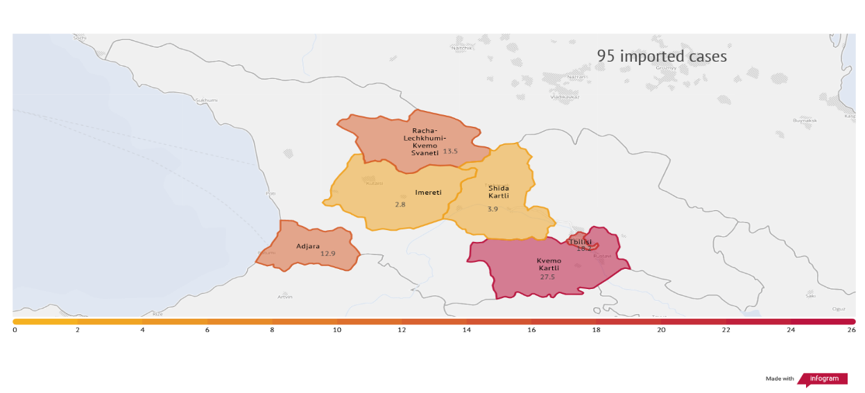

One of the important strategies for managing COVID-19 pandemic is protection of the healthcare workers and prevention of their infecting. Medical personnel often play a leading role in the infection transmission. The source of infecting the healthcare professionals worldwide is not only the patient, but also the shortage of personal protective equipment (representing one of the significant risk - factors), as well as family and community contacts. According to various sources, the frequency of infecting the healthcare professionals fluctuate from 5% to 20% ,.
During the study period, infecting of healthcare workers was reported in 13% of COVID-19 confirmed cases in Georgia.
Hospitalization: According to the Ministerial Order N 01-119 /O of March 24, all patients with confirmed coronavirus disease of any level of severity are to be hospitalized.
Pursuant to the Order N01-136 / O (March 30, 2020) on Designation of so-called Fever Centers for Preventing Spread of Potential COVID-19 Cases (epidemy, pandemic, epidemic outbreak) and Readiness to Respond to Potential and/ or Confirmed Cases, the services provided by Fever Clinics include triage of all fever cases, diagnostics of COVID-19 infection in accordance with the algorithm approved by the Ministry, determination of further treatment tactics and referral of confirmed cases to the respective facility.
The first recovered patient was discharged from the clinic on March 16. As of May 11, the total number of recovered patients constituted 317.
Figure 7. Cumulative number of PCR confirmed cases and recoveries (as of May 11, 2020)

Figure 8. Daily number of PCR confirmed and recovered cases (as of May 11, 2020)
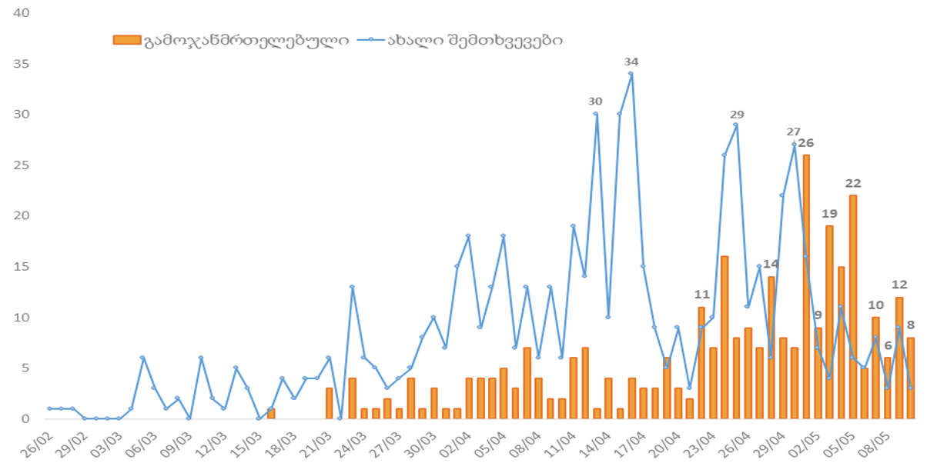
Recovered
New cases
Contact tracing, quarantine: Prior to hospitalization, in case of each patient, contacts were traced, their laboratory testing was conducted and telephone or face-to-face interviews were held about contacts, travel, existing symptoms of the infected persons and other parameters. Outbreak clusters have been identified through epidemiological investigation. The most notable of the large clusters were the Bolnisi and Kobuleti clusters, where additional investigation was performed.

As of May 11, up to 3,500 contacts were traced across the country through an epidemiological investigation of confirmed cases. In order to follow-up on the contacts, they were self-isolated or taken to a special quarantine area and further monitored.

According to data available as of May 11, 2020, more than 20,000 persons (close contacts of cases and those from highly - affected areas) were transferred to quarantine space.

Figure 9. The number of quarantined persons for the purpose of preventing COVID-19 spread
(as of May 11, 2020)
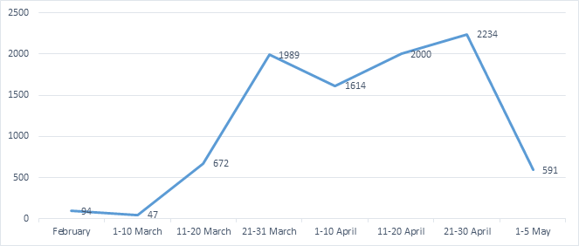

Mortality due to COVID-19: As of May 11, the total number of deaths in Georgia due to COVID-19 was 10, and the fatality rate equaled 1.7%. 6 cases of death were registered in Tbilisi, 3 in Kvemo Kartli and 1 in Adjara.

Map 2. Distribution of COVID-19 deaths by place of residence (as of May 11, 2020)

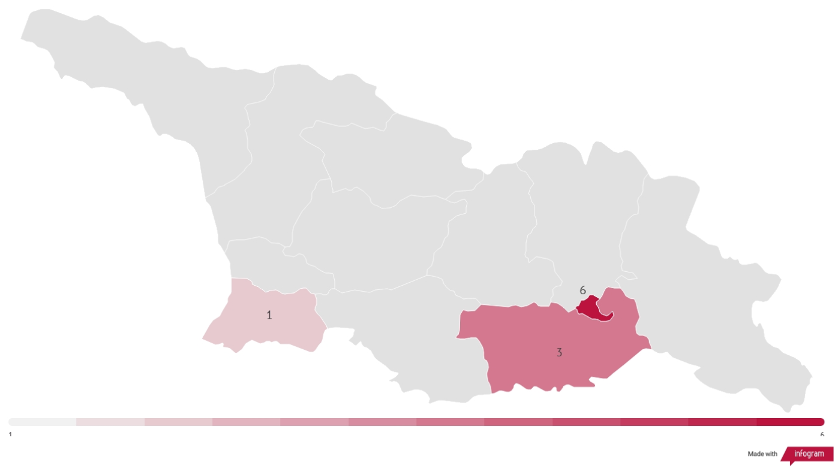
Apart from the number of COVID-19 infected cases, excess mortality is considered in many countries as one of the most significant indicators, to assess the impact (if any) the fast spread of the disease and associated deaths had on the mortality rate.

Excess mortality is defined as the mortality rate in the general population that exceeds the expected rate caused by a particular disease. Relatively high mortality rates for this stage (11.05.2020) are observed in Belgium, France, Sweden, Spain, Italy, England and the Netherlands.

The total number of deaths in Georgia in the first three months of 2020 was 12,474, which is 4% less than the number of deaths (12,989) in the same period of 2019. In 2019, the same figure was 5% higher compared to the first quarter of the previous year (the total number of deaths in 2018 - 12,245).

Figure 10. The number of deaths in the first quarter, Georgia, 2018 – 2020
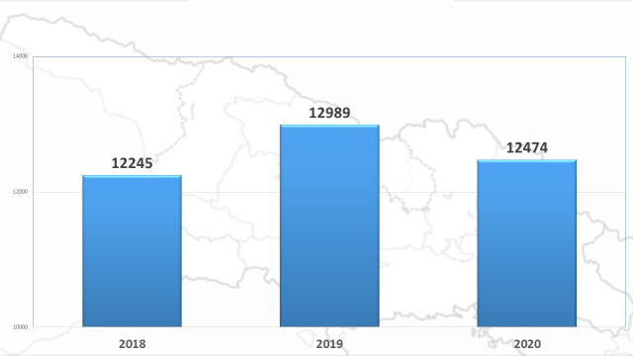

Figure 11. Gender –age distribution of COVID -19 deaths (as of May 11, 2020)
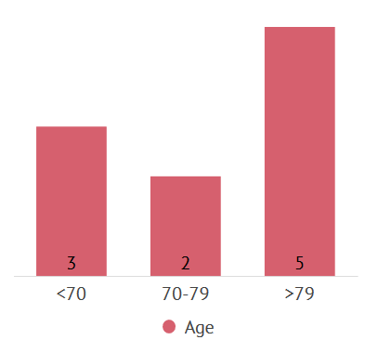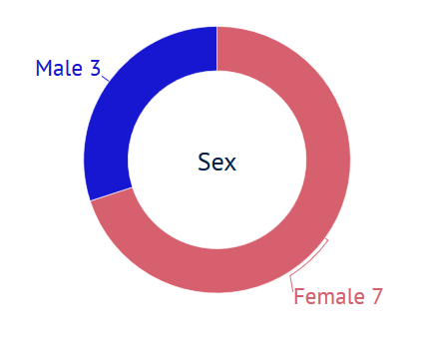

Figure 12. Distribution of COVID-19 caused deaths by the thanatogenetic chain of the main causes of death
(as of May 11, 2020)

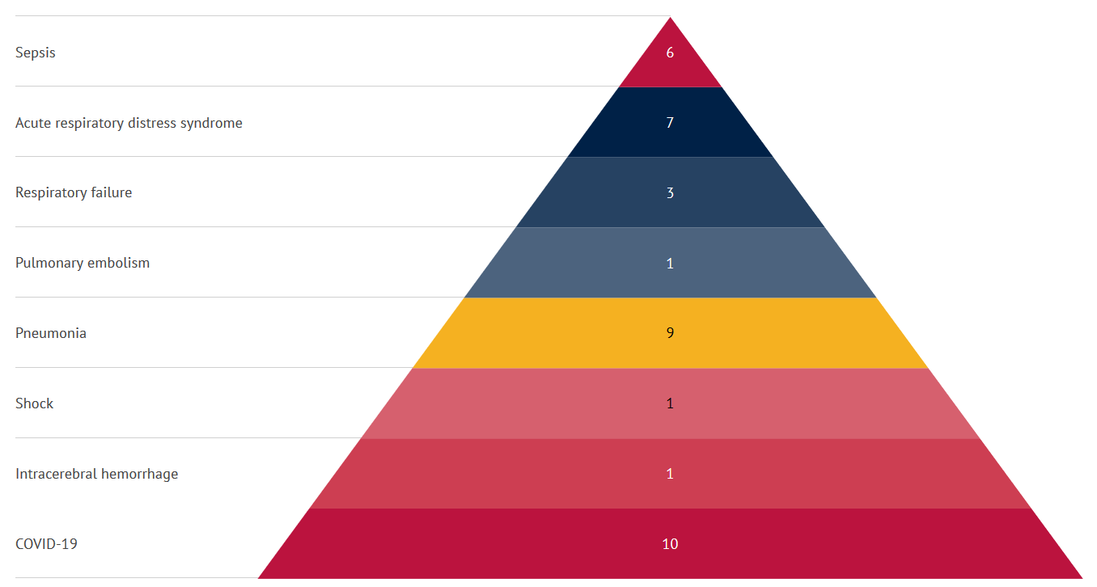

Figure 13. Distribution of COVID-19 deaths by concomitant diseases (as of May 11, 2020)

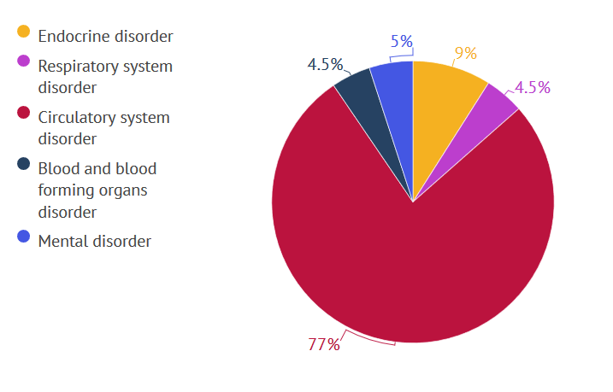
Figure 14. History of inpatient treatment in 2014-2019 of persons deceased due to COVID-19 (as of May 11, 2020)
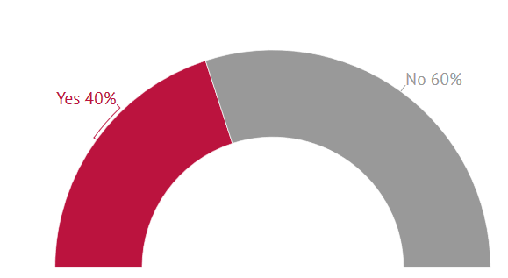

Communication campaign related to COVID-19: Informational and educational materials were prepared, published and disseminated, including for ethnic minorities in Armenian and Azerbaijani languages; evidence-based educational materials are being translated and adapted continuously from CDC and WHO and other international sources. Visual materials, educational posts, infographics, video materials were made and disseminated through their social network. In collaboration with the donor organizations, informative electronic banners were created and posted on various websites and video portals. Also, several video clips were made in partnership with the donor organizations. At the beginning of the pandemic, informative advertisements on street monitors were prepared and posted.
Work is underway to develop risk communication and community engagement strategies in partnership with the United Nations Children's Fund (UNICEF), the World Health Organization (WHO), and various government agencies.

NCDC Hotline - 116 001: Receiving of calls to the hotline of the National Center for Disease Control and Public Health with respect to COVID-19 issues began on January 23, 2020. In order to respond appropriately, a total of 43 people were gradually trained to perform the function of an operator on the hotline, including:
- Employees hired under the labor contract for the Center hotline - 3;
- Employees of the Medical Statistics Department of the Center - 11;
- Employees of the Non-Communicable Diseases Department of the Center - 14;
- Employees hired under labor contract within the scope of Hepatitis C State Program - 6;
- Volunteer students (Tbilisi State Medical University) - 9.
Hotline work hours:
- Working days: 09:00 - 23:00
- Non-working days: 10:00 - 20:00
Management of incoming calls received at the hotline has significantly contributed to stopping non-purposeful referrals of patients to medical facilities . At the initial stage of the pandemic, under conditions of informational shortage and panic, the bulk of the population’s calls was being directed exactly to 116 001. It should be noted that the public confidence in the Center hotline during this period was quite high, to which also contributed the launch of so-called feedback principle – reverse communication to callers and provision of further detailed responses to asked questions regarding numerous issues.
The total number of calls received by the hotline from January 23 to May 11, 2020, was 39 885, including:
- Answered: 32 061 Call (80%)
- Missed: 7,824 calls (20%).

Figure 15. Total number of incoming calls during the period from
January 23 to May 11, 2020 on the hotline

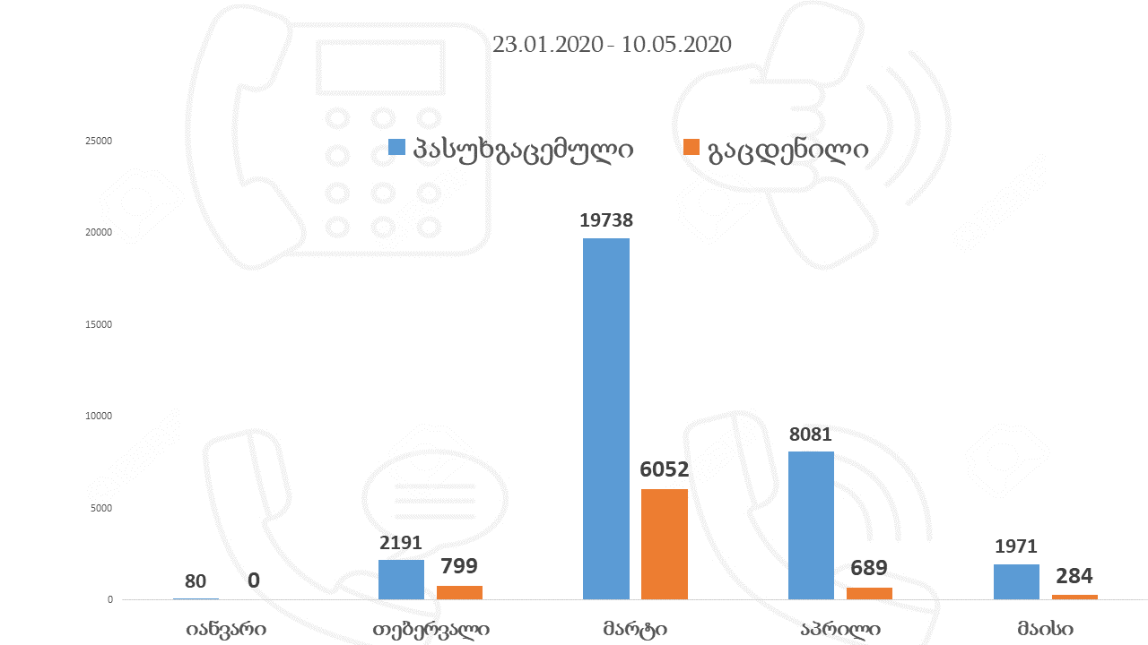
Answered
Missed
January February March April May

Epidemiological characteristics of 500 new coronavirus infection cases registered in Georgia after February 26, 2020

Descriptive study

Methods and variables
Epidemiological characteristics of the first 500 COVID-19 infection cases registered since February 26, 2020 in Georgia and confirmed with PCR method were analyzed retrospectively within the framework of the descriptive study. The analysis included the following areas:
- Characteristics of gender, age and geographic distribution;
- Characteristics related to the course of the disease, symptoms and concomitant conditions;
- Test-related features;
- Results of contacts and cluster research;
- Characteristics related to medical personnel.

The disease incidence figure for the surveyed period is calculated as the ratio of the number of new confirmed cases (500) to the population at risk.

Data Sources
The main source of information on COVID-19 infected persons is represented by the Electronic Integrated Disease Surveillance System (EIDSS), which aims to strengthen and support monitoring and prevention of human and animal diseases within the scope of the One Health Concept and ensure application of International Health Regulations (IHR) 2005. Disease-specific information, samples, case-related laboratory data and total figures are managed by means of EIDSS. Pursuant to the Order # 01-27N of May 2012, the EIDSS is an official reporting system for public health facilities and agencies under the Ministry of Health. It is possible to adapt its configuration to the needs of the country according to the changed requirements, such as the list of diseases, official reports, disease-specific research forms, and more.
Data were also validated through special protocols completed during the epidemiological study.

Study Results

Characteristics of gender, age and geographic distribution: The study analyzed data on 500 new coronavirus infection cases confirmed with PCR method including 243 (48.6%) male and 257 (51.4%) female patients. The maximum age of patients was 90 years and the minimum 9 months. Average age and median was 42 years. COVID -19 in patients under the age of 18, was reported in 60 (12%) cases.

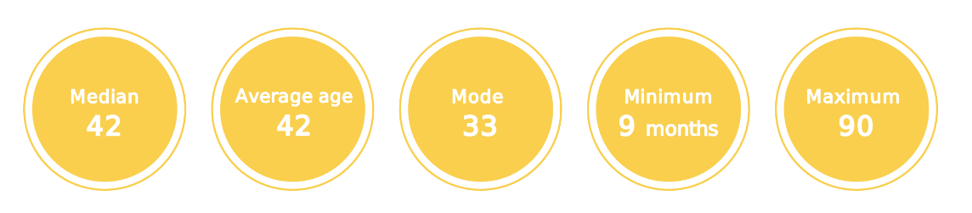

Table 2. Distribution of confirmed COVID -19 cases by age and gender (n = 500)
Age groups | Number | %
0 - 14 | 43 | 9%
15 - 19 | 27 | 5%
20 - 29 | 70 | 14%
30 - 69 | 318 | 64%
70 + | 42 | 8%
Total | 500 | 100%
Gender | Number | %
Male | 243 | 48.6%
Female | 257 | 51.4%

Figure 16. Distribution of COVID - 19 confirmed cases by age (n = 500)

Figure 17. Distribution of confirmed COVID - 19 cases by gender (n = 500)

81% of the registered cases was infected on the territory of Georgia.

Characteristics related to the disease symptoms and underlying health conditions: Within the scope of the research, the presence of disease related clinical symptoms and underlying health conditions was analyzed for each patient prior to hospitalization.

Figure 18. Clinical characteristics of COVID – 19 confirmed cases - symptoms prior to hospitalization (%) (n = 500)

The most common symptoms are fever (82.4%, 95% CI 78.40% - 85.93%), general weakness (49.6%, 95% CI 44.70% - 54.51%), cough (38.3%, 95% CI 33.61% - 43.16%), sore throat (25.9%, 95% CI 21.76% - 30.39%) and headache (22.5%, 95% CI 18.58% - 26.82%). Of the 500 cases, 83 cases were asymptomatic during PCR testing. Accordingly, the proportion of asymptomatic cases was 16.6% (95% CI 13.44% - 20.16 %).

It is noteworthy that more than one symptom was observed in 57.6% of patients (288 cases), of which 55.1% in male (134 cases) and 59.9% in female (154 cases) patients.

Table 3. Distribution of COVID - 19 confirmed cases according to clinical characteristics - symptoms prior to hospitalization (n = 500)
Symptoms | Male |  | Female |  | Both
Symptoms | Number | % | Number | % | Number | %
Fever /Shiver | 171 | 85 | 173 | 80 | 344 | 82,4
General weakness | 96 | 47.7 | 111 | 51.3 | 207 | 49.6
Cough | 69 | 34.3 | 91 | 42.1 | 160 | 38.3
Dry / sore throat | 54 | 26.8 | 54 | 25 | 108 | 25.9
Headache | 49 | 24.3 | 45 | 20.8 | 94 | 22.5
Rhinitis | 35 | 17.4 | 31 | 14.3 | 66 | 15.8
Muscle pain | 25 | 12.4 | 33 | 15.2 | 58 | 13.9
Heavy breathing | 20 | 9.9 | 22 | 10.1 | 42 | 10
Joint pain | 18 | 8.9 | 20 | 9.2 | 38 | 9.1
Stomach ache | 7 | 3.4 | 23 | 10.6 | 30 | 7.1
Nausea | 13 | 6.4 | 16 | 7.4 | 29 | 6.9
Chest pain | 16 | 7.9 | 11 | 5 | 27 | 6.4
Conjunctivitis | 9 | 4.4 | 2 | 0.9 | 11 | 2.6
Change in taste and smell | 26 | 12.9 | 36 | 16.6 | 62 | 14.8
Diarrhea | 26 | 12.9 | 25 | 11.5 | 51 | 12.2
Asymptomatic | 42 | 17.3 | 41 | 16.0 | 83 | 16.6

Figure 19. COVID - 19 confirmed cases by symptom onset and confirmation dates (n = 500)

Among the most common concomitant diseases there were hypertension (10%), diabetes (4%) and kidney disease (2%). In women, concomitant disease was more common than in men.

Table 4. Distribution of COVID - 19 confirmed cases according to clinical characteristics - concomitant diseases prior to hospitalization, percentage of confirmed cases in the total number (n = 500)
 | Both genders |  | Male |  | Female
 | Number | % | Number | % | Number | %
Hypertension | 48 | 9.6 | 18 | 7.4 | 30 | 11.7
Diabetes | 20 | 4 | 9 | 3.7 | 11 | 4.3
Kidney disease | 10 | 2 | 3 | 1.2 | 7 | 2.7
Chronic lung disease | 8 | 1.6 | 4 | 1.6 | 4 | 1.6
Chronic neurological disease | 8 | 1.6 | 2 | 0.8 | 6 | 2.3
Cancer | 4 | 0.8 | 3 | 1.2 | 1 | 0.4
Liver disease | 2 | 0.4 | 0 | 0 | 2 | 0.8

Characteristics of 168 patients diagnosed with novel coronavirus and discharged from hospitals (as of May 11, 2020)

Descriptive study

Methods and Variables

The present study retrospectively analyzed the data on 168 patients diagnosed with novel coronavirus and discharged from the hospital in Georgia from February 26 to May 10, 2020. Diagnosis of these patients was confirmed with PCR method.
The analysis included the following characteristics:
- The type of hospital referral
- Gender / age structure
- Geographical distribution of patients
- Characteristics related to underlying health conditions / diseases
- Complications by age / gender
- Studies used to diagnose complications (pneumonia, etc.) (radiography, CT Scan, MRI);
- Pregnancy during hospitalization
- Bed - days
- Treatment outcome

Data Sources

The main sources of information on hospitalized patients diagnosed with COVID - 19 were:

- Electronic module for registration of patients discharged from inpatient facility (Form IV - 066) (Order of the Minister of Internally Displaced Persons from the Occupied Territories, Labor, Health and Social Affairs of Georgia N01 - 43 / N of April 16, 2020);
- A special questionnaire filled out for each patient.

Study Results

Type of hospital referral: Majority (72.0%) of the 168 patients covered by the research were delivered to hospital by ambulance.

Figure 20. Percentage distribution by the referral type of patients diagnosed with COVID – 19 and discharged from the inpatient facility (n = 168) (as of May 11, 2020)

Gender/ age structure: The study analyzed data on 168 patients, including 80 (47.6%) male and 88 (52.4%) female patients. The maximum age of patients was 86 and the minimum 2. The average age of the patients was 43 years.

Among patients the share of 30 - 69 year olds was 64.3%, while the share of 0 to 15 year old children was 4.8%.

Figure 21. Distribution by age groups of COVID – 19 diagnosed patients discharged from hospital (n = 168) (as of May 11, 2020)

Figure 22. Distribution by gender of COVID – 19 diagnosed patients discharged from the hospital (n = 168) (as of May 11, 2020)

Table 5. Distribution by the place of hospitalization of COVID – 19 diagnosed patients discharged from hospital (n = 168) (as of May 11, 2020)
 | Both genders | Share (%)
Tbilisi | 117 | 69.6
Shida Kartli | 21 | 12.5
Adjara | 14 | 8.3
Imereti | 14 | 8.3
Samegrelo da Zemo Svaneti | 2 | 1.2
Georgia | 168 | 100

The cases were stratified according to the severity of the disease at the time of hospitalization.

Bed – days spent at hospital: The highest number of bed – days was spent by patients of 30 – 69 -year age group, with no significant gender differences.

Table 6. Distribution by age and gender of COVID – 19 diagnosed patients discharged from hospital (n = 168)
(as of May 11, 2020)
Age groups | Spent bed - days  (Both genders N) | Spent bed days  (Female patients N) | Spent bed days  (Male patients N)
0 - 14 | 172 | 81 | 91
15 - 19 | 224 | 114 | 110
20 - 29 | 517 | 207 | 310
30 - 69 | 2 292 | 1 261 | 1 031
70 + | 268 | 111 | 157
Total | 3 473 | 1 774 | 1 699

Complications: The average number of bed - days spent at hospital by the patients covered by study was 20.7.
Pneumonia was observed in 24 cases (14.3%) among the 168 hospitalized patients, and 13 (7.7%) developed acute respiratory distress syndrome.

Table 7. Distribution by concomitant diseases and complications of COVID – 19 diagnosed patients discharged from hospital (n = 168) (as of May 11, 2020)
Concomitant diseases: 17 cases (10 %)
Hypertension | Diabetes | Cardiovascular diseases | Chronic respiratory diseases |  | Cancer |  | Viral hepatitis
7 (4.2%) | 1 (0.6%) | 4 (2.4%) | 1 (0.6%) |  | 3 (1.8%) |  | 1 (0.6%)
Complications: 61 cases (36 %)
Pneumonia | Other respiratory diseases, which predominantly damage interstitium |  |  | Including respiratory distress syndrome of adults |  | Shortness of Breath
24 (14.3%) | 14 (8.3%) |  |  | 13 (7.7%) |  | 10 (5.9%)

Treatment outcome: 162 (96.4%) cases of recovery were registered among patients discharged from hospitals covered by study, 6 cases ended with lethal outcome (mortality rate - 3.6%). The deceased mostly belonged to the age group over 70.

Table 8. Distribution by bed – days and outcome of hospitalized cases diagnosed with COVID - 19 (n = 168)
(as of May 11, 2020)
Number of bed - days | Recovered | Deceased
Day <10 | 6 | 2
Day 11 - 20 | 71 | 2
Day 21 - 30 | 77 | 2
Day 31 - 40 | 7 | 0
Day 40 and more | 1 | 0
Total | 162 (96%) | 6 (4%)

CONCLUSION

The document prepared by the National Center for Disease Control and Public Health, covering analysis of the measures taken by the Center and descriptive study (including 500 patients starting with the first confirmed case and the hospitalized and discharged 168 patients) representing interesting information both for local and international partners.

The effective measures taken by Georgia have to some extent reduced the growing number of infection cases. Despite the achieved results, the intensive implementation of preventive / restraining measures, detection of infected persons through testing, contact tracing and following isolation remain as important directions for managing epidemy in the country. The existing approach should be further strengthened.

ACKNOWLEDGMENTS

The National Center for Disease Control and Public Health extends its appreciation to the Coordination Council established by the Government of Georgia, the Ministry of Health and all other agencies within the Council for their support in implementation of the measures taken in accordance with the recommendations.

The Center expresses its special gratitude to all the international and local organizations that supported its operations during the difficult period. This assistance made it possible to maximize effectiveness of implemented activities. More than 40 organizations have provided technical and / or financial assistance to the National Center for Disease Control. The complete list of these organizations and the letter of appreciation are posted at the official Facebook page of the Center.
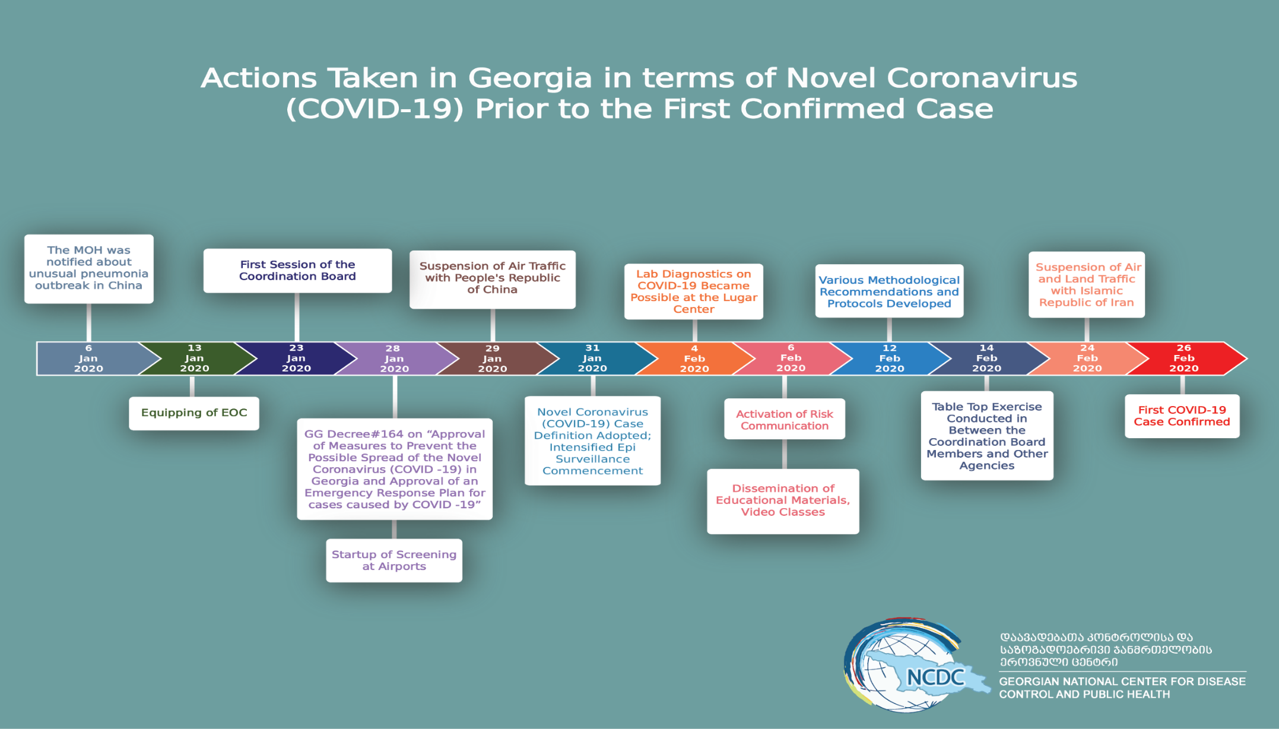
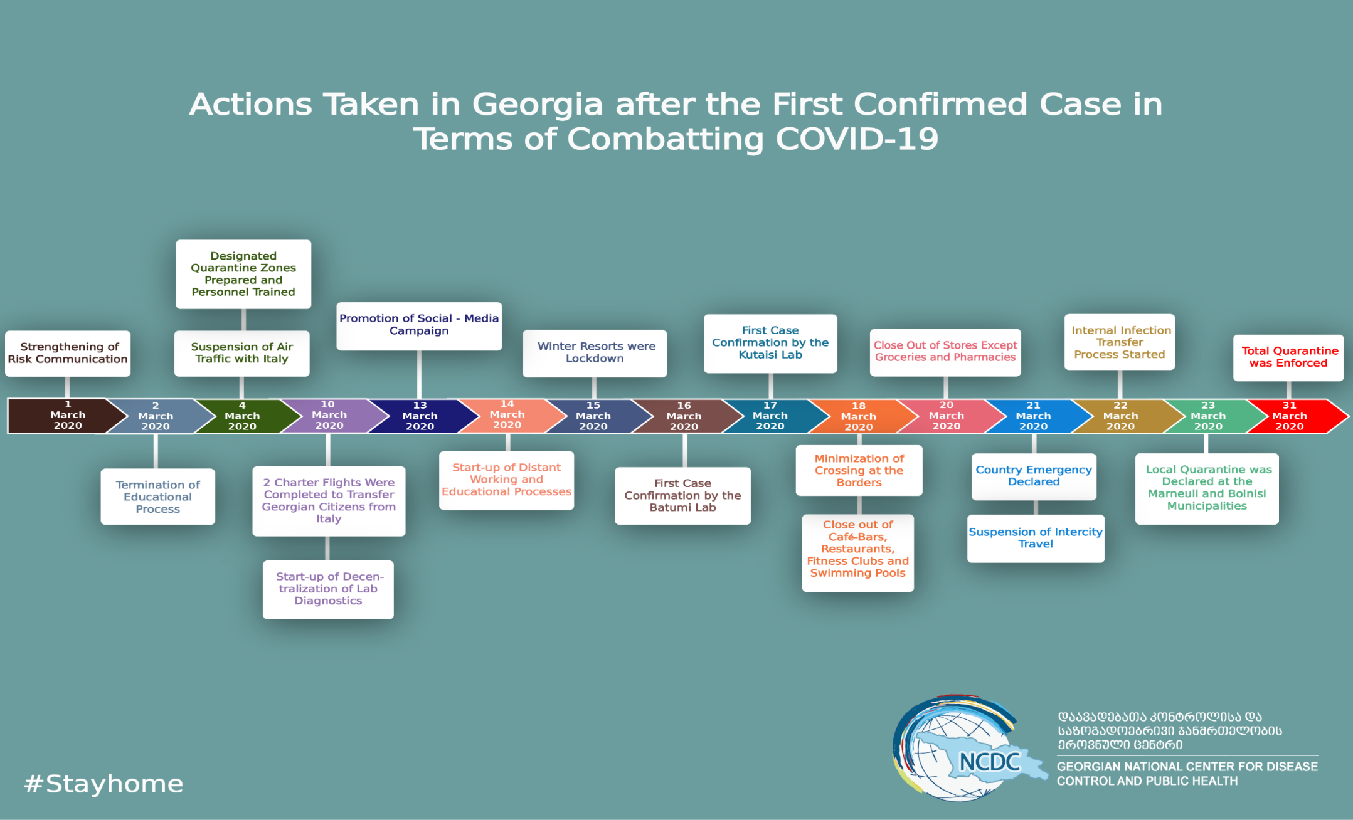

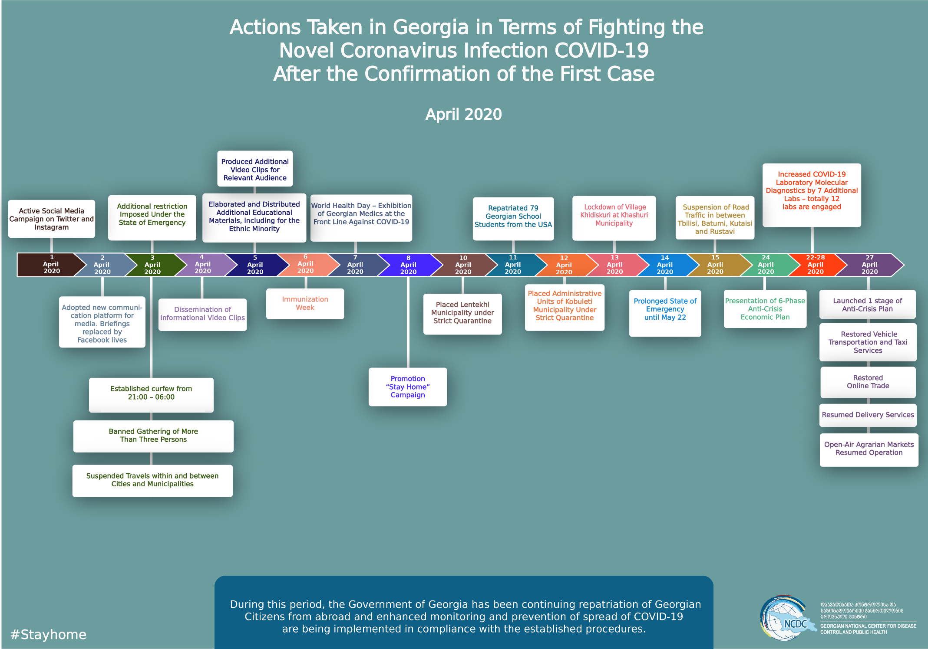

Information on activities implemented against COVID – 19 is presented in the form of an annex.
Real time reverse transcription polymerase chain reaction / RT – PCR
https://www.ncdc.ge/Pages/User/News.aspx?ID=d6eba28f-4851-4d1d-a184-2a85992c7109
European Centre for Disease Prevention and Control. Contact tracing: public health management of persons, including healthcare workers, having had contact with COVID-19 cases in the European Union – second update, 8 April 2020. Stockholm: ECDC, 2020
The Lancet. First experience of COVID-19 screening of health-care workers in England. Vol 395 May 2, 2020
Determination of concomitant disease variable on the basis of medical history collected during epidemiological research
An asymptomatic laboratory-confirmed case is a person infected with COVID-19 who does not develop symptoms (WHO Coronavirus disease 2019 (COVID-19) Situation Report - 73). These 83 cases were asymptomatic on the day of PCR testing, however with the course of the disease, certain symptoms could have appeared later. Detailed research of the clinical course for each case is ongoing and the figure will be updated in the next report.
The present paper provides data received only from Form N 66; the missing figures will be filled after obtaining/ processing questionnaires from the medical institutions.

